YATE user manual

**CALL BETWEEN EXTENSIONS**

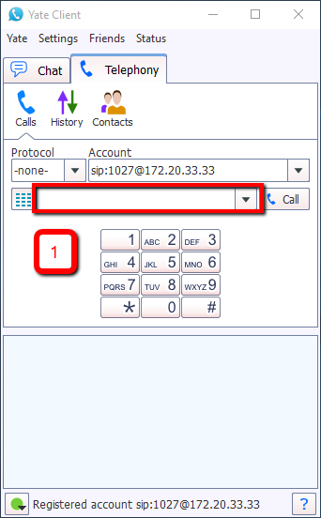Step 1: Enter the extension number in the box

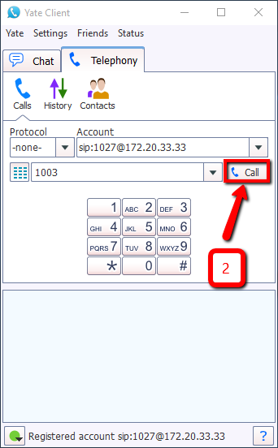Step 2: Press “Call” icon.

**CALL EXTERNAL NUMBERS.**

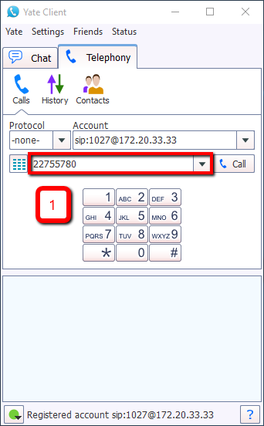Step 1: Enter the number in the box

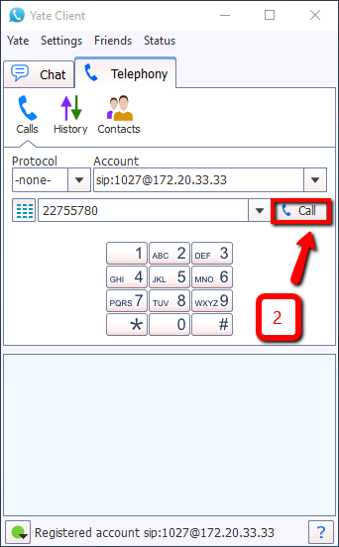Step 2: Press “Call” icon.

Step 3: Enter provided PIN followed by the # key.

**VOICEMAIL**

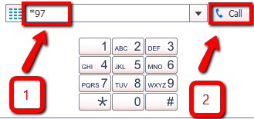Step 1: Enter *97 in the box

Step 2: Press “Call” icon.

Step 3: Enter provided voicemail password followed by the # key.

**CALL ON HOLD**

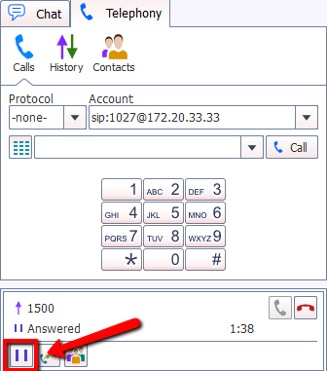To place a call on hold or resume a previously set call on toggle press the “Pause” icon.

**CONFERENCE**

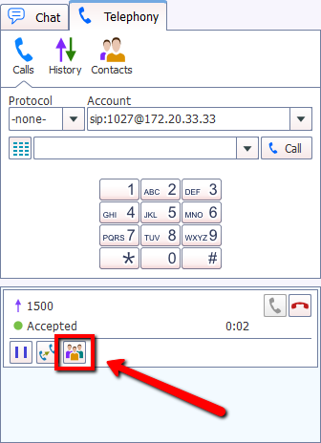Step 1: Press the “Conference” icon.

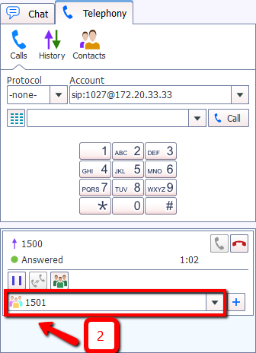Step 2: Enter the extension number or telephone number to be added to the call in the prompted box.

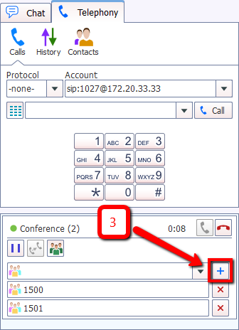Step 3: Press “Addition” icon.